|  |  |
| --- | --- |
| **Ex. No: 2** | **CSS enabled CV** |
| **20.07.2023** |

**Aim:**

To apply CSS to the Assignment done for LAB 1

**Algorithm:**

1. Create a CSS file
2. Link the CSS file to the HTML file
3. Define Styles
4. Apply Classes and IDs
5. Preview and Refine.

**Program:**

<!DOCTYPE html>

<html>

<head>

<title>ASHresume</title>

<style>

body {

margin-left: 20%;

margin-right: 20%;

font-family:Calibri, sans-serif;

}

.bluetextitalics {

color : #003579;

font-style: italic;

}

.blacktextitalics {

color: black;

font-style: italic;

}

.stickit {

margin-top: 0px; margin-bottom: 0px;

}

h1 {font-size: 21pt;}

h2, h3 {font-size: 11pt; line-height: 13pt; text-align: left; }

p {font-size: 11pt; line-height: 13pt;}

</style>

</head>

<body>

<!-- Header div -->

<div class="stickit">

<h1 style="text-align: center; margin-bottom: 2px ;" class="bluetextitalics">Amoghavarsh Hiremath</h1>

<h3 style="text-align: center; margin-top: 0px ; margin-bottom: 4px;">Karnataka, India</h3>

<div style=" display: flex; align-items: center; justify-content: center;">

<h3 style="margin-right:20px;margin-top: 0px; "> <span class="bluetextitalics">Phone number : </span>+91 63608 03602 </h3>

<h3 style="margin-top: 0px; "> <span class="bluetextitalics ">Email Id : </span>amoghash80@gmail.com</h3>

</div>

</div>

<br>

<!-- Education -->

<h2 class="bluetextitalics stickit" style="margin-bottom: 0px;">Education</h2>

<hr style="margin-top: 0px; color: #003579;">

<div style="padding-left: 25px;">

<h3 class="stickit">B-Tech: Computer Science with Specialization in IoT </h3>

<p class="blacktextitalics stickit" > Shiv Nadar University Chennai Bachelor’s degree program | (5th Semester ongoing) | 2021-2025</p>

<p class="blacktextitalics stickit" >GPA: 8.6</p>

<h3 class="stickit">Class XII </h3>

<p class="blacktextitalics stickit" > Jambagi PU College | Department of Pre-University Education(Karnataka) | 2020-2021</p>

<p class="blacktextitalics stickit" >Final precentage: 97%</p>

<h3 class="stickit">Class X </h3>

<p class="blacktextitalics stickit" >Phoenix Public School | Indian Certificate of Secondary Education Examination (ICSE) | 2018-2019</p>

<p class="blacktextitalics stickit" >Final precentage: 90.2%</p>

</div>

<br>

<!-- Projects -->

<h2 class="bluetextitalics stickit" style="margin-bottom: 0px;">Portfolio of most relevant project</h2>

<hr style="margin-top: 0px; color: #003579;">

<div style="padding-left: 25px;">

<h3 class="stickit" >StepWise<span style="text-align: right;">| Python, Streamlit, HTML-CSS,Arduino,ESP-32 Cam,OpenCV |</span></h3>

<ul class="stickit ">

<li data-list-text="•">

<p class="stickit">A footfall management application for analyzing the footfall data by performance metrics in a

store given from the ESP-32 Camera module with Arduino by Human Detection using OpenCV.</p>

</li>

<li data-list-text="•">

<p class="stickit">Aids the shopkeepers in knowing potential and performance of aisles to

make marketing and advertising decisions on their products.</p>

</li>

</ul>

<h3 class="stickit" >SocioPath<span style="text-align: right;">| HTML-CSS,JavaScript,ReactJS |</span></h3>

<ul class="stickit ">

<li data-list-text="•">

<p class="stickit">An application which helps startups find guidance, funding and support,

connecting people from all the different fields to professionals alike.</p>

</li>

<li data-list-text="•">

<p class="stickit">Provides an environment which supports innovations and solutions to grow.</p>

</li>

</ul>

<h3 class="stickit" >Traffic Alert System<span style="text-align: right;">| Arduino,HC-SR04,Buzzer |</span></h3>

<ul class="stickit ">

<li data-list-text="•">

<p class="stickit">A prototype that uses Arduino and the HC-SR04 UV module to alert inattentive drivers on road that are approaching a stop light.</p>

</li>

<li data-list-text="•">

<p class="stickit">Prevents accidents and keeps people from braking the rules.</p>

</li>

</ul>

</div>

<br>

<!-- skills -->

<h2 class="bluetextitalics stickit" style="margin-bottom: 0px;">Skills</h2>

<hr style="margin-top: 0px; color: #003579;">

<div style="padding-left: 25px;">

<h3 class="stickit" >Technical/Tools</h3>

<p class="stickit">C, C++,Python,SQL, Java, JavaScript, HTML, CSS, Tailwind CSS, Tableau,Data Science and Analytics,

Data Structures and Algorithms,Competitive Programming, Arduino, Raspberry Pi.</p>

<h3 class="stickit" >General/Tools</h3>

<p class="stickit">Problem Solving, Communication, Flexibility</p>

</div>

<br>

<!-- Achievements and Certifications -->

<h2 class="bluetextitalics stickit" style="margin-bottom: 0px;">Achievements and Certifications</h2>

<hr style="margin-top: 0px; color: #003579;">

<table style="border-collapse:collapse;margin-left:24.844pt" cellspacing="0">

<tr style="height:15pt">

<td style="width:186pt">

<p class="stickit" style="padding-left: 2pt;text-align: left;">Introduction to Soft Computing</p>

</td>

<td style="width:119pt">

<p class="stickit" style="padding-left: 15pt;text-align: left;">April 2023</p>

</td>

<td style="width:179pt">

<p class="stickit" style="padding-right: 3pt;text-align: right;">NPTEL</p>

</td>

</tr>

<tr style="height:15pt">

<td style="width:186pt">

<p class="stickit" style="padding-left: 2pt;text-align: left;">Data Science for Engineers</p>

</td>

<td style="width:119pt">

<p class="stickit" style="padding-left: 15pt;text-align: left;">April 2023</p>

</td>

<td style="width:179pt">

<p class="stickit" style="padding-right: 3pt;text-align: right;">NPTEL</p>

</td>

</tr>

<tr style="height:15pt">

<td style="width:186pt">

<p class="stickit" style="padding-left: 2pt;text-align: left;">SOI MUMPS Microfabrication Process</p>

</td>

<td style="width:119pt">

<p class="stickit" style="padding-left: 15pt;text-align: left;">March 2023</p>

</td>

<td style="width:179pt">

<p class="stickit" style="padding-right: 3pt;text-align: right;">Shiv Nadar University Chennai</p>

</td>

</tr>

<tr style="height:15pt">

<td style="width:186pt">

<p class="stickit" style="padding-left: 2pt;text-align: left;">Codeforces</p>

</td>

<td style="width:119pt">

<p class="stickit" style="padding-left: 15pt;text-align: left;">Max Rated 848</p>

</td>

<td style="width:179pt">

<p class="stickit" style="padding-right: 3pt;text-align: right;">Handle-ashtrichh</p>

</td>

</tr>

</table>

</body>

</html>

**Output:**

Github Link: https://github.com/AsHtrich/Web_tech2023

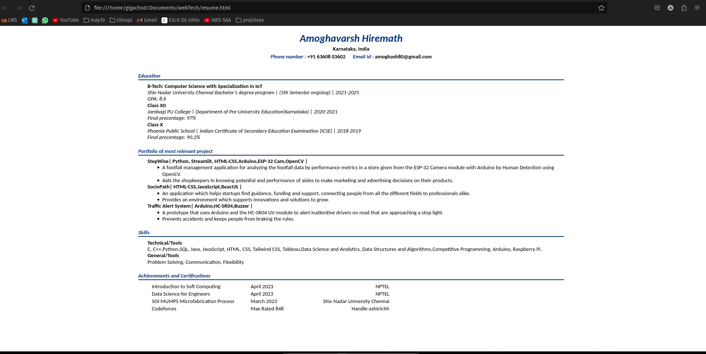

**Result:**

Therefore, we've successfully implemented the creation of Thread using C.